**GENERAL & ANALYTICAL CHEMISTRY I**

**CHMG.141**

With Dr. Bailey Name____________

Recitation

Week11

**Chemical Reactions**

**Part A**

Problem 1: Predict the products and balance each of the following equations. What type is each reaction? If no reaction occurs, then simply write “NO REACTION”:

1. NaNO3(aq) + KCl(aq) 🡪
2. K3PO4(aq) + NiCl2(aq) 🡪
3. NH4Cl(aq) + AgNO3(aq) 🡪
4. NaOH(aq) + HNO3(aq) 🡪
5. K2S(aq) + HCl (aq) 🡪

Problem 2: Balance each of the following equations.

Write balanced **complete ionic and net ionic equation** for each of the reactions:

1. K2SO4(aq) + CaCl2(aq) 🡪 CaSO4(s) + KCl(aq)
2. HCl(aq) + LiOH(aq) 🡪 H2O(l) + LiCl(aq)

**Part B**

Problem 1: Determine the oxidation number for each element in the following compounds:

HClO4 NaClO CH4 (NH4)3PO4 CO32-

Problem 2: Determine if any of the following reactions are redox reactions.

If so, identify the substance being oxidized and which is being reduced.

Identify the oxidizing agent and the reducing agent.

* 1. CH4(g) + 2O2(g) → CO2(g) + 2H2O(g)
  2. Zn(s) + 2HCl(aq) → ZnCl2(aq) + H2(g)
  3. 5 Cr3+(aq) + 3MnO41-(aq) + 8 H2O(l) 🡪 5 CrO42-(aq) + 3Mn2+(aq) + 16H1+
  4. Cr2O7-2(aq) + 2OH-1(aq) → 2CrO4-2(aq) + H2O(l)
  5. 2CuCl(aq) → CuCl2(aq) + Cu(s)

**Part C:**

**Balancing Ox/Red Reactions**

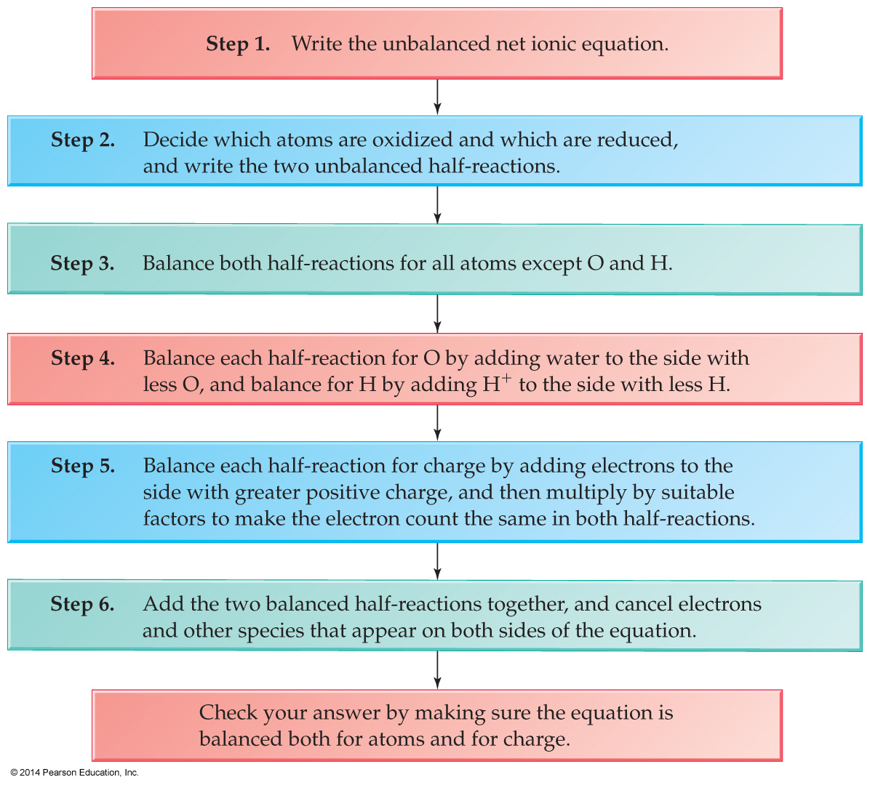

Problem 1: Balance the following reaction in (a) **acidic solution** and (b) **basic solution**

MnO2 (s) + H3AsO3 (aq) → Mn2+ (aq) + H3AsO4 (aq)

1. *Acidic solution*
2. Split the reaction into two half-reactions.
3. Consider the following half reaction:

MnO2 (s) → Mn2+ (aq)

Balance everything but oxygen and hydrogen atoms.

1. Take your answer to (2) and balance the oxygen by adding a water to add oxygen where needed.
2. Take your answer to (3) and balance the hydrogen by adding in H+ where needed (do not forget the charge on the H+!).
3. Take your answer to (4) and balance the charges by adding electrons to the more positive side of the reaction until the charges are equal.
4. Balance the other half reaction in the same way

H3AsO3 (aq) → H3AsO4 (aq)

1. Combine the half reactions to eliminate the electrons
2. “Clean up”: cancel other species that appear on both sides of the equation.

*(b) Basic solution*

Add OH- to both sides of the equation to neutralize H+

Problem 2 (optional, for your practice):

Balance the following reaction in basic solution

CrO4 2- (aq) + I2 (s) → Cr(OH)3 (s) + IO3 - (aq)